

**DEPARTMENT**

**OF**

**ELECTRONICS & COMMUNICATION ENGINEERING**

**Digital Communication System**

**(Theory Notes)**

**Autonomous Course**

**Prepared by**

**Prof. Navya Holla K**

|  |
| --- |
| **Module – 1 Information Theory** |
| **Digital Communication block diagram, Information, Entropy, Shannon’s Encoding Algorithm, Huffman coding, Discrete memoryless channels, BSC, channel capacity, Shannon Hartley Theorem and its implications.** |

**Dayananda Sagar College of Engineering**

**Shavige Malleshwara Hills, Kumaraswamy Layout,**

**Banashankari, Bangalore-560078, Karnataka**

**Tel : +91 80 26662226 26661104 Extn : 2731 Fax : +90 80 2666 0789**

**Web - http://www.dayanandasagar.edu Email : hod-ece@dayanandasagar.edu**

**( An Autonomous Institute Affiliated to VTU, Approved by AICTE & ISO 9001:2008 Certified )**

**( Accredited by NBA, National Assessment & Accreditation Council (NAAC) with 'A' grade )**

* 1. **Digital Communication block diagram**

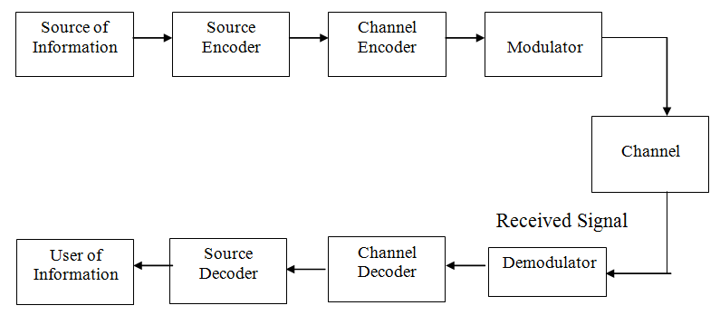

Fig. 1: Elements of digital communication system.

* + 1. **Information source:**

The source of information can be analog or digital, e.g. analog: audio or video signal, digital: like teletype signal. In digital communication the signal produced by this source is converted into digital signal which consists of 1′s and 0′s.

* + 1. **Source Encoder**

The Source encoder (or Source coder) converts the input i.e. symbol sequence into a binary sequence of 0‟s and 1‟s by assigning code words to the symbols in the input sequence. For eg. :-If a source set is having hundred symbols, then the number of bits used to represent each symbol will be 7 because 27=128 unique combinations are available. The important parameters of a source encoder are block size, code word lengths, average data rate and the efficiencyof the coder (i.e. actual output data rate compared to the minimum achievable rate)

At the receiver, the source decoder converts the binary output of the channel decoder into a symbol sequence. The decoder for a system using fixed – length code words are quite simple, but the decoder for a system using variable – length code words will be very complex.

Aim of the source coding is to remove the redundancy in the transmitting information, so that bandwidth required for transmission is minimized. Based on the probability of the symbol code word is assigned. Higher the probability, shorter is the code word.

Ex: Huffman coding.

* + 1. **Channel Encoder**

Error control is accomplished by the channel coding operation that consists of systematically adding extra bits to the output of the source coder. These extra bits do not convey any information but helps the receiver to detect and / or correct some of the errors in the information bearing bits.

There are two methods of channel coding:

* Block Coding: The encoder takes a block of “k” information bits from the source encoder and adds “r” error control bits, where “r” is dependent on “k” and error control capabilities desired.
* Convolution Coding: The information bearing message stream is encoded in a continuous fashion by continuously interleaving information bits and error control bits.

The Channel decoder recovers the information bearing bits from the coded binary stream. Error detection and possible correction is also performed by the channel decoder.

The important parameters of coder / decoder are: Method of coding, efficiency, error control capabilities and complexity of the circuit.

**1.1.4** **Modulator**

It is performed for the efficient transmission of the signal over the channel. The modulator operates by keying shifts in the amplitude, frequency or phase of a sinusoidal carrier wave to the channel encoder output. The digital modulation techniques are referred to as amplitude- shift keying, frequency- shift keying or phase-shift keying respectively. The Modulator converts the input bit stream into an electrical waveform suitable for transmission over the communication channel. Modulator can be effectively used to minimize the effects of channel noise, to match the frequency spectrum of transmitted signal with channel characteristics, to provide the capability to multiplex many signals.

The detector performs demodulation, thereby producing a signal the follows the time variations in the channel encoder output. The modulator, channel and detector form a discrete channel (because both its input and output signals are in discrete form.

* + 1. **Channel**

The Channel provides the electrical connection between the source and destination. The different channels are: Pair of wires, Coaxial cable, Optical fibre, Radio channel, Satellitechannel or combination of any of these.

The communication channels have only finite Bandwidth, non-ideal frequency response, the signal often suffers amplitude and phase distortion as it travels over the channel. Also, the signal power decreases due to the attenuation of the channel. The signal is corrupted by unwanted, unpredictable electrical signals referred to as noise.

The important parameters of the channel are Signal to Noise power Ratio (SNR), usable bandwidth, amplitude and phase response and the statistical properties of noise.

**1.2. Information**

The output of a discrete information source is a message that consists of a sequence of symbols. The actual message that is emitted by the source during a message interval is selected at random from a set of possible messages. The communication system is designed to reproduce at the receiver either exactly or approximately the message emitted by the source.

To measure the information content of a message quantitatively, we are required to arrive at

an intuitive concept of the amount of information.

Consider the examples: A trip to Miami, Florida from Minneapolis in the winter time,

* mild and sunny day,
* cold day,
* possible snow flurries.

The amount of information received is obviously different for these messages.

* The first message contains very little information since the weather in Miami is mild and sunny most of the time.
* The forecast of a cold day contains more information since it is not an event that occurs often.
* In contrast, the forecast of snow flurries conveys even more information since the occurrence of snow in Miami is a rare event.

Thus on intuitive basis the amount of information received from the knowledge of occurrence of an event is related to the probability or the likelihood of occurrence of the event. The message associated with an event least likely to occur contains most information.

The information content of a message can be expressed quantitatively in terms of probabilities as follows:

Suppose an information source emits one of ‘q’ possible messages m1, m2 …… mq with p1, p2 …… pq as their probs. of occurrence. Based on the above intusion, the information content of the kth message, can be written as

I ($m_{k})α\frac{1}{p_{k}}$

Also to satisfy the intuitive concept, of information.

I (mk) must $→$  zero as pk $→$ 1

Therefore,

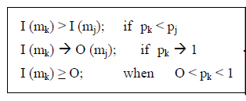

Another requirement is that when two independent messages are received, the total information content is – Sum of the information conveyed by each of the messages.

Thus the equation becomes



Whrere mk and mj are two independent messages.

A continuous function of p that satisfies the constraints specified in the above equations is the logarithmic function and we can define a measure of information as



The base for the logarithmic in equation determines the unit assigned to the information content.

Natural logarithm base : ‘nat’

Base - 10 : Hartley / decit

Base - 2 : bit

Using the binary digit as the unit of information is based on the fact that if two possible binary digits occur with equal proby (p1 = p2 =½) then the correct identification of the binary digit conveys an amount of information. I (m1) = I (m2) = – log2 (½ ) = 1 bit. Therefore one bit is the amount of information that we gain when one of two possible and equally likely events occurs.

Ex1:

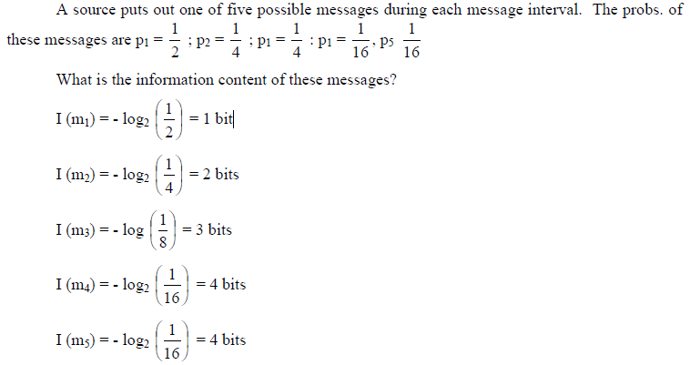

**1.3 Entropy**

Suppose a source that emits one of *M* possible symbols s1, s2,……sM in a statistically independent sequence. Let p1,p2…….pq be the probabilities of occurrence of the *M* symbols, respectively. In a long message containing *N* symbols, the symbol s1will occur on the average p1Ntimes, the symbol s2 will occur p2Ntimes, and in general the symbol sM will occur pMN times. The information content of the ith symbol is I (si)= $\log_{2}\left(\frac{1}{p_{i}}\right).$

Therefore p1N number of messages of type s1 contains bits. Similarly p2N number of messages of type s1 contains $p_{2}N\log_{2}\left(\frac{1}{p_{2}}\right)$ bits.

$∴$ Total self-information contains all these messages as

$I_{total}=$ $p_{1}N\log_{2}\left(\frac{1}{p_{1}}\right)+p_{2}N\log_{2}\left(\frac{1}{p_{2}}\right)+…………….+p_{M}N\log_{2}\left(\frac{1}{p_{M}}\right)$

$I_{total}=N\sum_{i=1}^{M}{p_{i}N\log_{2}\left(\frac{1}{p_{i}}\right)}$ bits

The average information *per* symbol is obtainedby dividing the total information content of the message by the number of symbols in the message, as

$Entropy=H=\frac{T_{total}}{N}=\sum_{i=1}^{M}{p_{i}N\log_{2}\left(\frac{1}{p_{i}}\right)}$ bits/symbol

**1.3.1 Average information rate**

If the symbols are emitted by source at a fixed time rate rs, then the average information rate

Rs is given by $R_{s}=r_{s}*H$ bits/sec

Eamples:

1. Consider a discrete memoryless source with a source alphabet A= ( $s_{0,}s_{1,}s_{2})$ with respective probabilities $p_{0}=\frac{1}{4}$, $p_{1}=\frac{1}{4}$, $p_{2}=\frac{1}{2}$. Find the entropy of the source.

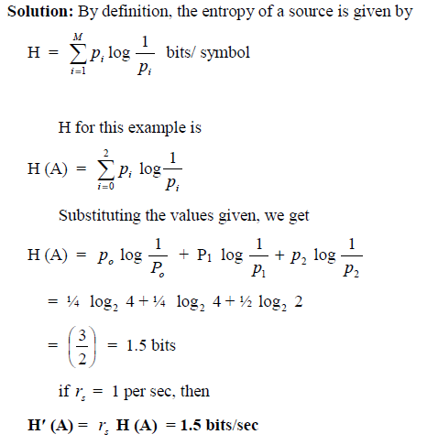

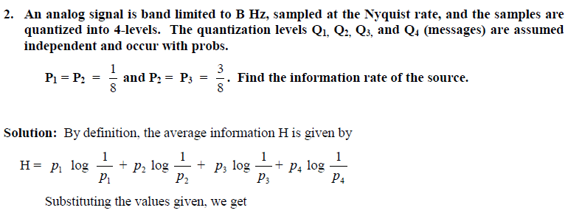

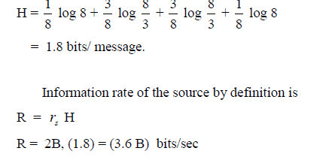

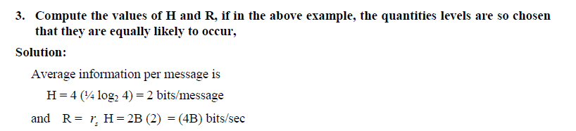

* 1. **Shannon’s Encoding algorithm**

Source encoding is the process by which the output of an information source is converted in to an r-array sequence. Coding is nothing but transformation of each of the source symbol s={$s_{1,}s_{2,}s_{3}……..s_{q}$) suing the symbols from the source alphabet X={$q_{1,}q_{2,}q_{3}……..q_{r}$).

In binary coding r represents number of different symbols used in the code alphabet. That is r=2 => X={0,1). In general if {$s_{1,}s_{2,}s_{3}……..s_{q}$) are to be transmitted, then q number of different starts are required. In binary coding only 2 states are required. Hence the transmission process becomes much easier and efficiency of the system can be increased.

* Let the source symbols in the order of decreasing probabilities

S={$s_{1,}s_{2,}s_{3}……..s_{q}$)

P={$p_{1,}p_{2,}p_{3}……..p_{q}$).

$p_{1}≥p_{2}≥p_{3}…….≥p_{q}$

* Compute the sequence

$α_{1}$ =0

$α_{2}$ = $p_{1}=p_{1+}α_{1}$

$$α_{3}=p_{2}+p_{1}=p_{2}+α_{2}$$

$$α_{4}={p_{3}+p}_{2}+p_{1}=p_{3}+α_{3}$$

.

.

$α_{q+1}={p_{q}+α}_{q}=1$

* Determine the smallest integer for $l_{i}$ (length of code word) using the inequality

$2^{l^{i}}≥\frac{1}{p_{i}}$ for all i=1 to q

* Expand the decimal numbers $α_{i}$ in binary form up to $l_{i}$ places neglecting the expansion beyond $l_{i}$ places.
* Remove the decimal point to get the desired code.

**Code efficiency:** The average length ‘L’ of any code is given by $L=\sum_{i=1}^{q}{p_{i}L_{i}}$ where $L_{i}=l_{1}l_{2}l_{3}l_{4}…….l_{q}$

Code efficiency, $η_{c}=\frac{H(S)}{L }*100$ for binary codes.

**Ex: 1**. Construct the Shannon’s binary code for the following message symbols S={$s_{1,}s_{2,}s_{3},s_{4}$) with probabilities P=(0.4, 0.3,0.2,0.1).

**Solution:**

* ***0.4 > 0.3 > 0.2 > 0.1***
* ***0 = 0,***

***1 = 0.4***

***2 = 0.4+0.3=0.7***

***3= 0.7+0.2=0.9***

***4= 0.9 + 0.1 = 1.0***

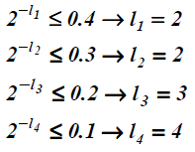

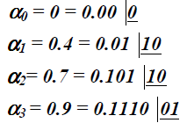

* The codes are

***s1*** ***00, s2*** ***01, s3*** ***101, s4*** ***1110***

The average length of this code is

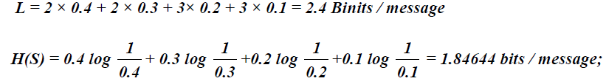



**Ex: 2:** Apply Shannon’s binary encoding procedure to the following set of messages and obtain code efficiency and redundancy.

1/8, 1/16, 3/16, 1/4, 3/8

**Solution:**

**Ex: 3:** Repeat the above messages **($x_{1,}x_{2,}x_{3})$** with P=(1/2, 1/5, 3/10)

Solution:

* 1. **Huffman Coding**
* The source symbols are listed in the decreasing order of probabilities.
* Check if *q = r +* a*(r-1)*is satisfied and find the integer ‘a***’***, where q is number of source symbols and r is number of symbols used in cod alphabets. ‘a***’*** values is calculated and it should be an integer,otherwise add suitable number of dummy symbols of zero probability of occurrence to satisfy the equation. This step is not required if we are to determine binary codes.
* Combine the last ***r*** symbols into a single composite symbol whose probability of occurrence is equal to the sum of the probabilities of occurrence of the last ***r*** – symbols involved in the step.
* Repeat the above three stepsrespectively on the resulting set of symbols until in the final step exactly ***r***- symbols are left.
* The last source with ‘r’ symbols are encoded with ‘r’ different codes 0,1,2,3,….r-1
* In binary coding the last source are encoded with 0 and 1
* As we pass from source to source working backward, decomposition of one code word each time is done in order to form 2 new code words.
* This procedure is repeated till we assign the code words to all the source symbols of alphabet of source ‘s’ discarding the dummy symbols.

Ex:

**1.6 Discrete memoryless Channel**:

A channel is defined as the medium through which the coded signals are generated by an information source are transmitted. In general, the input to the channel is a symbol belonging to an alphabet ‘A’ with ‘r’ symbols, the output of a channel is a symbol belonging to an alphabet ‘B’ with ‘s’ symbols.

Due to errors in the channel, the output symbols may differ from input symbols.

**1.6.1 Representation of a channel:**

A communication channel may be represented by a set of input alphabets A=($a_{1,}a_{2,}a_{3}……..a_{r}$) consisting of ‘r’ symbols and set of output alphabets B=($b_{1,}b_{2,}b_{3}……..b_{s}$) consisting of s symbols and a set of conditional probability P( ${b_{i}}/{a_{i}})$ with i=1,2,….r and j=1,2,…….s

$A \left.\begin{matrix}a_{1} \\ a_{\begin{aligned}2 \\ ⋮\end{aligned}} \\ a_{r}\end{matrix}\right\}→$ P(${b_{i}}/{a_{i}})→\left\{\begin{matrix}b_{1} \\ b_{\begin{aligned}2 \\ ⋮\end{aligned}} \\ b_{s}\end{matrix}\right. B$

The conditional probabilities come in to the existence due to the presence of noise in the channel. Because of noise there will be some amount of uncertainty in the reception of any symbols. For this reason there are ‘s’ number of symbols at the receiver from ‘r’ symbols at transmitter. Totally there are r * s conditional probabilities represented in a form of matrix which is called as Channel Matrix or Noise Matrix.

When $a_{1}$ is transmitted, it can be received as any one of the output symbols ($b_{1,}b_{2,}b_{3}……..b_{s}$)

Therefore $P_{11}+P_{12}+P_{13}+……P_{S}$ =1

=>P(${b_{1}}/{a_{1}})$ + P(${b_{2}}/{a_{1}})$ + P(${b_{3}}/{a_{1}})$ +…………….. P(${b_{s}}/{a_{1}})$ =1

In general, $\sum_{j=1}^{s}{P({b_{j}}/{a_{i}})}=1$ for i= 1 to r

Thus the sum of all the elements in any row of the channel matrix is equal to UNITY.

**1.6.2 Joint Probability:**

Joint probability between any input symbol $a_{i}$ and any output symbol $b_{j}$ is given by P($a_{i}∩b_{j})=P(a_{i},b_{j})= P({b_{j}}/{a_{i}})P(a_{i})$

$P(a_{i},b_{j})$**= $P({a_{i}}/{b_{j}})P(b_{j})$**

**Properties:**

Consider the source alphabet A=($a_{1,}a_{2,}a_{3}……..a_{r}$) and output alphabet B=($b_{1,}b_{2,}b_{3}……..b_{s}$)

* The source entropy is given by $H\left(A\right)=\sum_{i=1}^{r}{P_{a_{i}}\log_{2}(\frac{1}{P_{a_{i}}})}$
* The entropy of the receiver or output is given by $H\left(B\right)=\sum_{j=1}^{s}{P_{b_{j}}\log_{2}(\frac{1}{P_{b_{j}}})}$
* If all the symbols are equi-probable, then maximum source entropy is

${H(A)}_{max}=\log_{2}r$

* Conditional Entropy: The entropy of input symbols $a_{1,}a_{2,}a_{3}……..a_{r}$ after the transmission and reception of particular output symbol $b_{j}$ is defined as conditional entropy, denoted by $H(A/{b_{j}})$
$$H\left(A/{b_{j}}\right)=\sum_{i=1}^{r}{ P\left({a_{i}}/{b_{j}}\right)\log_{2}\frac{1}{P\left({a_{i}}/{b_{j}}\right)}.}$$

* If the average value of all the conditional probability is taken as j varies from 1 to s denoted by $H\left(A/B\right)=\sum_{j=1}^{s}{P(b_{j})} H\left(A/{b_{j}}\right)$

= $\sum_{j=1}^{s}{\sum_{i=1}^{r}{P(b_{j})}} P\left({a_{i}}/{b_{j}}\right)\log_{2}\frac{1}{P\left({a_{i}}/{b_{j}}\right)}$

$H\left(A/B\right)$**= $\sum_{j=1}^{s}{\sum_{i=1}^{r}{P(}}a_{i}, b_{j}) \log_{2}\frac{1}{P({a_{i}}/{b_{j}})}$** isconditional entropy of transmitter

Similarly $H\left(B/A\right)$ **= $\sum_{i=1}^{r}{\sum_{j=1}^{s}{P(}}a_{i}, b_{j}) \log_{2}\frac{1}{P({b_{j}}/{a_{i}})}$** isconditional entropy of receiver.

* $H\left(A,B\right)$**= $\sum_{i=1}^{r}{\sum_{j=1}^{s}{P(}}a_{i}, b_{j}) \log_{2}\frac{1}{P(a_{i}, b_{j})}$** is joint conditional probability.

**1.6.3 Mutual Information:**

When an average amount of information H(x) is transmitted over a noisy channel, then an amount of information $H\left(x/y\right)$ is last in the channel. The balance of the information at the receiver is defined as Mutual Information I(x.y)

I(x,y)= H(x)- $H\left(x/y\right)$

= H(y)- $H\left(y/x\right)$

I( $x_{i})=log⁡(\frac{1}{P(x_{i})})$ and $I\left({x_{i}}/{y_{j}}\right)=log({\frac{1}{P\left({x_{i}}/{y_{j}}\right)}}$

The difference between the above 2 is the information gained through the channel.

I($x_{i},y_{j})=\log\left(\frac{1}{P\left(x_{i}\right)}\right)-log⁡({\frac{1}{P\left({x_{i}}/{y_{j}}\right)}})$

I($x_{i},y_{j})=\log{\frac{P\left({x_{i}}/{y_{j}}\right)}{P\left(x_{i}\right)}}$

I($x_{i},y_{j})= \log{\frac{P(x_{i},y_{j})}{P\left(x_{i}\right)P\left(y_{j}\right)}}$

**Properties:**

* The Mutual Information is symmetric. I($x_{i},y_{j})=I(y_{j},x_{i})$